## **Waze**



Project goal:

Waze leadership has asked your data team to develop a machine learning model to predict user churn. An accurate model will help prevent churn, improve user retention, and grow Waze’s business.

Background:

Waze’s free navigation app makes it easier for drivers around the world to get to where they want to go. Waze’s community of map editors, beta testers, translators, partners, and users helps make each drive better and safer.

Scenario:

Your team is still in the early stages of their user churn project. So far, you’ve completed a project proposal, and used Python to inspect and organize Waze’s user data. Now, the data is ready for exploratory data analysis (EDA) and further data visualization.

Course 3 tasks:

* Clean data
* Handle outliers
* Perform EDA
* Visualize data
* Share an executive summary with the Waze data team

*Note: The story, all names, characters, and incidents portrayed in this project are fictitious. No identification with actual persons (living or deceased) is intended or should be inferred. And, the data shared in this project has been created for pedagogical purposes.*

## **Key Takeaways**

In Course 3, Go Beyond the Numbers: Translate Data into Insights, you explored the process of exploratory data analysis (EDA). You learned to Identify the core steps, basic methods, and benefits of structuring and cleaning data. Additionally, you investigated raw data using Python, and created data visualizations using Tableau

### **Course 3 skills:**

* Conduct exploratory data analysis
* Create data visualization with Tableau
* Expand knowledge of Python coding
* Share insights and ideas with stakeholders

### **Course 3 end-of-course project deliverables:**

* Complete EDA with workplace scenario dataset using Python
* Executive summary including a Tableau visualization

The end-of-course portfolio projects are designed for you to apply your data analytical skills within a workplace scenario. No matter which scenario you work with, you will practice your ability to discuss data analytic topics with coworkers, internal team members, and external clients.

# 

# 

# 

# 

# 

# 

# 

# 

# 

# 

# 

# **Course 3 end-of-course portfolio project overview: Waze**

# **Learn about the Course 3 Waze workplace scenario!**

The end-of-course project in Course 3 focuses on your ability to use exploratory data analysis to organize and understand the data within a project. As a reminder, in Course 1 you developed a project proposal that outlined milestones, which progress with each of the end-of-course projects. A visual representation is provided in the graphic shown here:

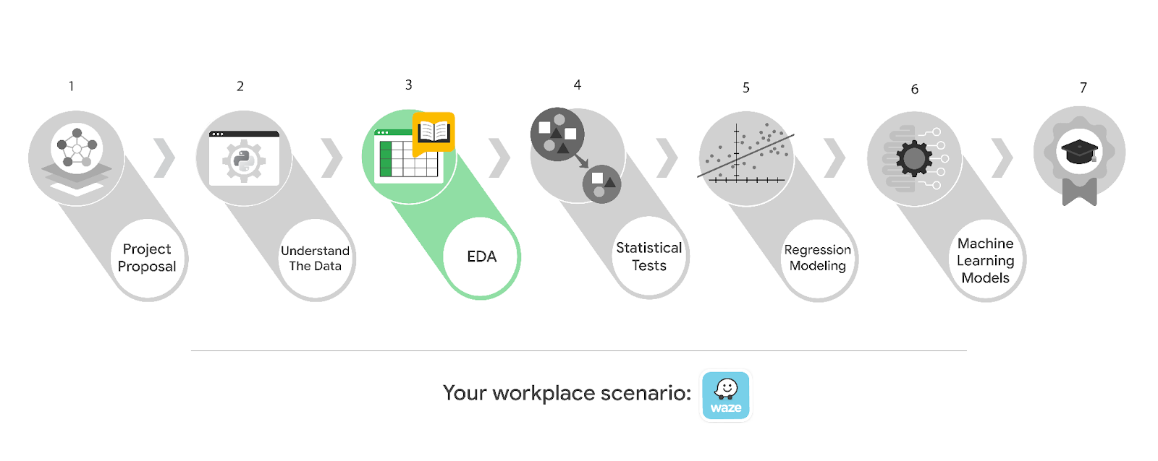

Learn more about the project, your role, and expectations in this reading.

## **Background on the Waze scenario**

Waze’s free navigation app makes it easier for drivers around the world to get to where they want to go. Waze’s community of map editors, beta testers, translators, partners, and users helps make each drive better and safer. Waze partners with cities, transportation authorities, broadcasters, businesses, and first responders to help as many people as possible travel more efficiently and safely.

You’ll collaborate with your Waze teammates to analyze and interpret data, generate valuable insights, and help leadership make informed business decisions. Your team is about to start a new project to help prevent user churn on the Waze app. Churn quantifies the number of users who have uninstalled the Waze app or stopped using the app. This project focuses on monthly user churn.

This project is part of a larger effort at Waze to increase growth. Typically, high retention rates indicate satisfied users who repeatedly use the Waze app over time. Developing a churn prediction model will help prevent churn, improve user retention, and grow Waze’s business. An accurate model can also help identify specific factors that contribute to churn and answer questions such as:

* Who are the users most likely to churn?
* Why do users churn?
* When do users churn?

For example, if Waze can identify a segment of users who are at high risk of churning, Waze can proactively engage these users with special offers to try and retain them. Otherwise, Waze may lose these users without knowing why.

Your insights will help Waze leadership optimize the company’s retention strategy, enhance user experience, and make data-driven decisions about product development.

### **Project background**

Waze’s data team is working on the churn project. The following tasks are needed before the team can begin the data analysis process:

* EDA and cleaning
* Select and build visualization(s) type
  + Create plots to visualize variables and relationships between variables
* Share your results with the data team

### **Your assignment**

You will conduct exploratory data analysis on data for the churn project. You’ll also use tools to create visuals for an executive summary to help non-technical stakeholders engage and interact with the data.

## **Team members at Waze**

### **Data team roles**

* Harriet Hadzic - Director of Data Analysis
* May Santner - Data Analysis Manager
* Chidi Ga - Senior Data Analyst
* Sylvester Esperanza - Senior Project Manager

Data team members have technical experience with data analysis and data science. However, you should always be sure to keep summaries and messages to these team members concise and to the point.

### **Cross-functional team members**

* Emrick Larson - Finance and Administration Department Head
* Ursula Sayo - Operations Manager

Your Waze team includes several managers overseeing operations. It is important to adapt your communication to their roles since their responsibilities are less technical.

*Note: The story, all names, characters, and incidents portrayed in this project are fictitious. No identification with actual persons (living or deceased) is intended or should be inferred. And, the data shared in this project has been created for pedagogical purposes.*

## **Specific project deliverables**

With this end-of-course project, you will gain valuable practice and apply your new skills as you complete the following:

* Complete the questions in the Course 3 PACE strategy document
* Answer the questions in the Jupyter notebook project file
* Clean your data, perform exploratory data analysis (EDA)
* Create data visualizations
* Create an executive summary to share your results

Good luck with this project! Your Waze team members are looking forward to seeing how you communicate your creative work and approach problem-solving!